MACHINE LEARNING

GITHUB LINK :

5TH ASSIGNMENT:

NAME :RAVURI VENKATARAMANA

STUDENT ID : 700741281

Q1)

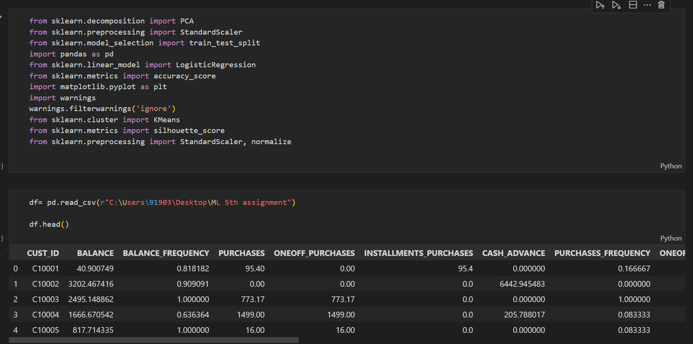

Q2)

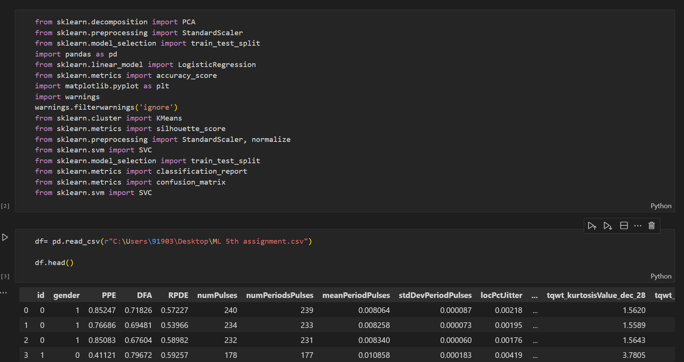

Q3)

Q4)

